Oscillation in a spring (by Per Sjunneson)
Last lab was about the force in a spring, today you are to use the result from that lab to do a simulation about how a weight hanging on a spring should behave.
Results from previous lab
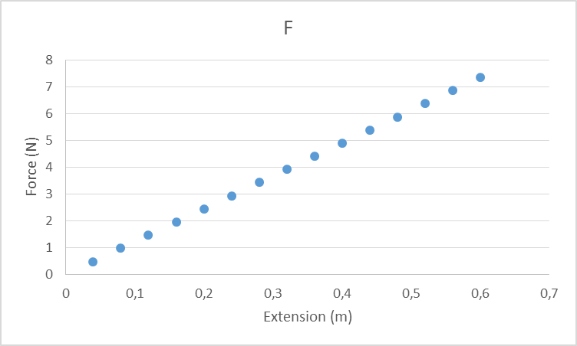
That looks like a straight line so a conclusion should be. But if you think about it the force on the weight is in opposite direction compared to the extension so it should look like
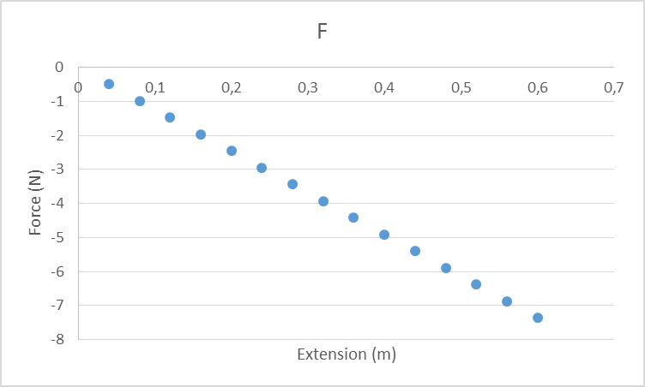
So the big conclusion from the previous lab is that the force on a weight from a spring can be calculated by or for short, where k is the “spring constant” and is a value telling us how hard it is to pull out a spring.

So today we will use this in excel to figure out how a weight hanging on an extended spring will behave when we let it go.
- Go on its learning open the excelfile “spring simulation student start”. Open it and activate so that you can edit the file.

Each column represent different data at different times. The cells marked in yellow have data that I have decided what it is the start of the event.
t (s): Is the time in seconds from when we start the clock. When we start the time is 0.
Δt (s): the change in time until the next data point that will be calculated.
s (m): Where the weight is compared to the equilibrium point (where the total force on the weight would be zero.)
k (N/m): The spring constant, how hard the spring is.
m (kg): The mass of the weight.
v (m/s): The velocity of the weight.

Ignore number of significant figures in all the background problems.

Background problem 1.
An object is moving with a velocity of 0.5 m/s, how far will the object move during a 0.001 s long time period.
- In excel, fix a formula for cell G2 to calculate Δs (m): The change in displacement.

Background problem 2.
An object is at displacement 0.2 m, the displacement changes with 0.0005 m. What is the new displacement?
- In excel, fix a formula for cell H2 to calculate new s (m): The new displacement.

Background problem 3.
In the previous lab we figured out that the force on a weight can be calculated by, .
Calculate the force on a weight if the displacement = 0.2005 m and the spring constant 15 N/m.

- In excel, fix a formula for cell I2 to calculate F (N): The force on the weight at the displacement given in cell H2.

Background problem 4.
Calculate the acceleration on a 0.7 kg mass when there is a -3.0075 N force is acting on it.

- In excel, fix a formula for cell J2 to calculate a (m/s²): The acceleration on the weight when the force given in cell I2 is acting on the weight.

Background problem 5.
Calculate the change of velocity on an object when you have an acceleration of -4.29 m/s² over a 0.001_s period.

- In excel, fix a formula for cell K2 to calculate Δv (m/s): The change of velocity during the time period given and an acceleration given in J2.

Background problem 6.
Calculate the new velocity of an object if the starting velocity is 0.5 m/s m and the change of velocity is -0.0043 m/s

- In excel, fix a formula for cell L2 to calculate new v (m/s): The new velocity of the weight.

Background problem 7.
An object with a mass of 0.7 kg is moving with a velocity of 0.5 m/s. Calculate the kinetic energy.

- In excel, fix a formula for cell O2 to calculate E_{k} (J): The kinetic energy of the weight.

Background problem 8.
The potential energy stored in a spring is given by
Calculate the potential energy when the spring constant is 15 N/m and the displacement is 0.2 m
- In excel, fix a formula for cell P2 to calculate E_{p} (J): The elastic potential energy stored in the spring.

Background problem 9.
Calculate the total energy when the potential energy is 0.0875 J and the kinetic energy is 0.3 J

- In excel, fix a formula for cell Q2 to calculate E_{tot} (J): The total energy of the system.

If you have managed to do this correct you should now have the following excel sheet.

Take note of the formulas that I had already written
A3=A2+B2: The new time is the old time plus the change of time.
B3=B2 We will continue to use the same change in time.
C3=H2 The new displacement is set to the displacement you calculated in H2.
D3=D2 We continue to use the same spring constant.
E3=E2 We continue to use the same mass
F3=L2 The new velocity is set to the velocity you calculated in L2

- Mark the area from G2 to Q2, copy down one row
- Mark the area from A3 to Q3, copy down one row.
- Fix the colors… yellow mean “Data given from the start”, Green mean “a value that stays constant”, Everything that is just copied from above should be white.
- Mark the area from A4 to Q4, copy down to about 3000 (three thousand) rows.

Now is the time to start playing with graphs, make sure to at least look at the following graphs. (I write 1st y-axis 2nd x-axis). It is ok (recommended) to delete the graphs to make room for new ones.
- v-t
- s-t
- a-t
- F-s
- a-s
- E_{k}-s
- E_{p}-s
And a few when you put in several different quantities at the same time. (I write x-axis last)
- s-v-t
- s-v-a-t (when you do change Δt to 0.003 s and k to 0.5 N/m)
- E_{k}-E_{p}-E_{tot}-s
Play around with adjusting the initial values (the one written on yellow) and see how that changes the graphs. You need to look at the numbers on the axis, Excel rescales the axis according to the values so if the highest value becomes 10 times bigger it will look the same unless you notice the values.

- Clean up (delete) extra graphs.
- Go back to the original initial values.
- Create a s-v-t graph and E_{k}-E_{p}-E_{tot}-s graph.
- Rename the file to “Spring simulation 1st_name” (so I would name it “Spring simulation Per”
- Upload the file on its learning

